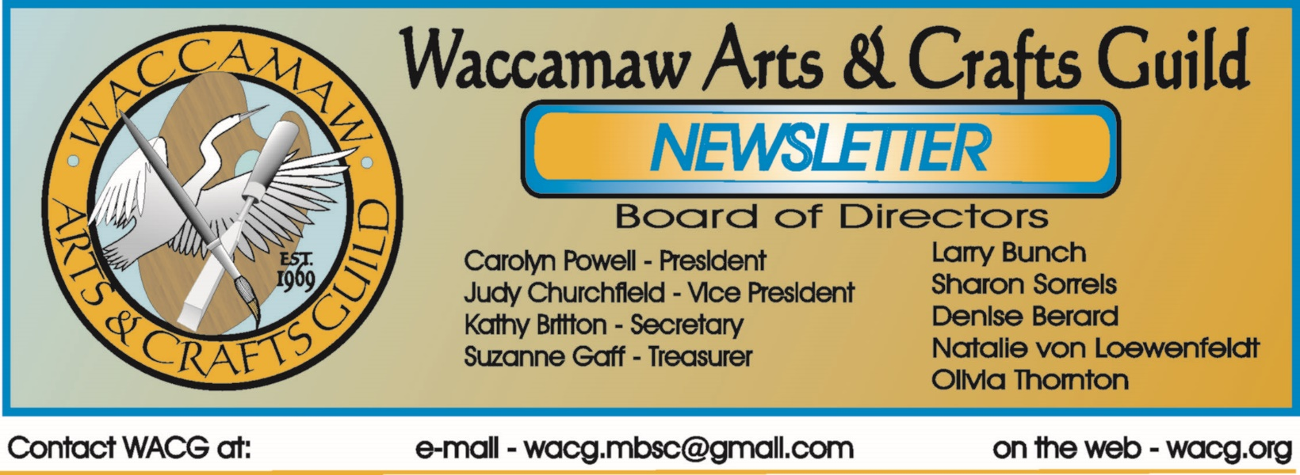
February 2016
Bits From The Board
After a good presentation stressing the importance of values in artwork by Annette Goings, the Board met briefly.
Tom updated us on the status of our new presence in social media: after much hard work and great anticipation the website is up and running! Be sure to check it out. Thanks to Tom and members who helped out with the site’s development. Members decided that in order to place an ad in the newsletter, a person or business needs to be a member or a major supporter of WACG.
We discussed the upcoming show and made some decisions regarding the programs and guest register at future shows. We asked Larry to contact the young man who played piano at last year’s show and arrange for him to play for us again this year. The Board tabled a discussion of further tweaking of future shows until our summer meetings, when we can give the matter our full attention.
We are waiting to hear from the high schools about the scholarship applications that we sent out; Sharon is keeping us updated on that process.
WACG will again have a presence at the HGHBA Home Show at the Myrtle Beach Convention Center this month. Art in the Park begins its’ forty fourth season in April with one event at Chapin Park and the second at Valor Park.
Hope to see everyone at these events and at our next meeting.
Carolyn Powell, President
Imagine, Create, Enjoy…
Looking Back
(Continued from January…)
The Art Museum would not open to the public until 1997 after major fund raising efforts by the Guild and Friends of Springmaid Villa. Moreover, the long process was not without controversy.
For a good while the Villa sat behind chain link fencing and a ladder was needed to access it, according to Dixie Dugan. Without funding, only small structural repairs were possible.
The gift of the 1.1 acre property from Myrtle Beach Farms opened up new avenues of funding that had been impossible as long as the building sat on leased land. The Close Foundation agreed to provide $60,000 if $100,000 could be raised by the guild and other members of the local arts community by May, 1988. That sum plus a little extra was raised with time to spare. Among the donors were Horry County Council, Myrtle Beach City Council, the Myrtle Beach Hotel/Motel Association, and numerous private individuals.
The Guild Board and City Council member Henry Charles figured that the $160,00 plus would enable the restoration of the first and second floors.
Opposition to a proposed oversight committee was mounted by the League of Independent Artists out of North Myrtle Beach. As a result of much discussion, the Springmaid Art Museum Corporation, a new non-profit charged with converting and later managing the property as a public art museum, was established.
The Franklin G. Burroughs – Simeon B. Chapin Art Museum (named in honor of and gratitude to the Myrtle Beach Farms owners) formally opened to the public in June, 1997.

Although the Guild no longer owns or has anything to do with management of the museum, our current monthly meetings and annual Juried Show there are an acknowledgement of the role of the Waccamaw Arts & Crafts Guild’s key role in establishing a public art presence in Myrtle Beach.
Show Dates
Home Show – (Convention Center) February 12th, 13th, 14th, 2016
Set-up – 2/11
This year we have a record number of artists participating. We will have to wait and see how that works out. It looks like we will have a wide variety of artistic goodies to sell. Given the amount of interest in the show, we will rethink the way we do things in the future. We are looking forward to a great show.

WACG Juried Show – (MB Art Museum)
April 28 – May 26
The prospectus is out now. If you need a copy you may go to the website and print it out. You must send it in with your check. There is no online payment option. Remember entries must be postmarked no later than February 22, 2016.
We have determined that our judge for the juried show will be Jim Arendt. You may recall that he recently had a show at the gallery titled “Works in Denim”. He is a professor at Coastal Carolina University and Director of the Rebecca Randall Bryan Gallery.
Art in the Park – (Chapin Park)
April 9th & 10th
June 11th & 12th
October 8th & 9th
November 5th & 6th

Art in the Park – (Valor Park)
April 16th & 17th
November 12th & 13th

Home Show – (Convention Center)
September TBD

Members Judged Show – (Seacoast Gallery)
October TBD
More information to follow.
Other Show I Event Info
The Myrtle Beach Art Museum has some interesting shows running until early to mid - April. You will probably want to check these out.

Frank Lloyd Wright: Architecture of the Interior
January 5th – April 7th
Recognized around the world for his innovative style and modern designs, Frank Lloyd Wright originated and popularized the concept that structures should exist in harmony with humanity and the environment, a philosophy he called organic architecture. The concept extended not only to the structures’ exteriors, but also to the interiors, furnishings and ornaments. The exhibition includes drawings, photographs of his most distinctive interiors.

Joe Quinn: Underwater
January 14th – April 21st
Originally from New York City, Quinn now lives in Myrtle Beach. He is a professional photographer who specializes in underwater, nature, documentary and fine art imagery. He is a member of the Ocean Artists Society and his work has been published in Asian Geographic, National Geographic, Smithsonian, and Dive News.

Charles Clary Infect[ious] Installations
Charles Clary of Morristown, TN currently teaches studio art at Coastal Carolina University. Some of you may recall his wonderful presentation at our November meeting. Using hand-cut, layered paper to build intriguing land formations that mimic viral colonies and concentric sound waves. His show presents us with the ideas of order out of chaos, beauty from distruction and hope for more joyous times. If you missed his presentation, you should see this show. If you saw his program, you have already planned to see it. The work is very interesting.

Kirkland Smith: Assemblages
January 21st – April 21st
Kirkland Smith was born in Charleston, South Carolina and currently resides in Columbia, SC. She earned a BA degree for the University of South Carolina in Studio

Arts, concentrating on ceramics and sculpture. In 2008, Kirkland entered an environmental art contest and almost by accident began creating contemporary Assemblages from post-consumer materials.
Meetings
Our next regular monthly meeting will be on February 21st, at 1:30PM at the Myrtle Beach Art Museum. Mark your calendars. The program will be presented by Rebecca Zdybel, a guild member who lives in Myrtle Beach, SC. She is a painter who teaches locally and abroad. Some of you may be familiar with her tours of Tuscany. It should be an interesting program.
As some of you will surely remember the December meeting was all about our history. Dixie Dugan and Alex Powers provided an interesting dialog relating to the founding of the Guild, the Art Museum beginnings. It was fun and fascinating. The video of this interview will become part of our digital history (scrapbook project). We had intended to publish a couple of photos from that meeting, but they didn’t get in the newsletter last month (blame the editor). So, “better late than never” here they are…
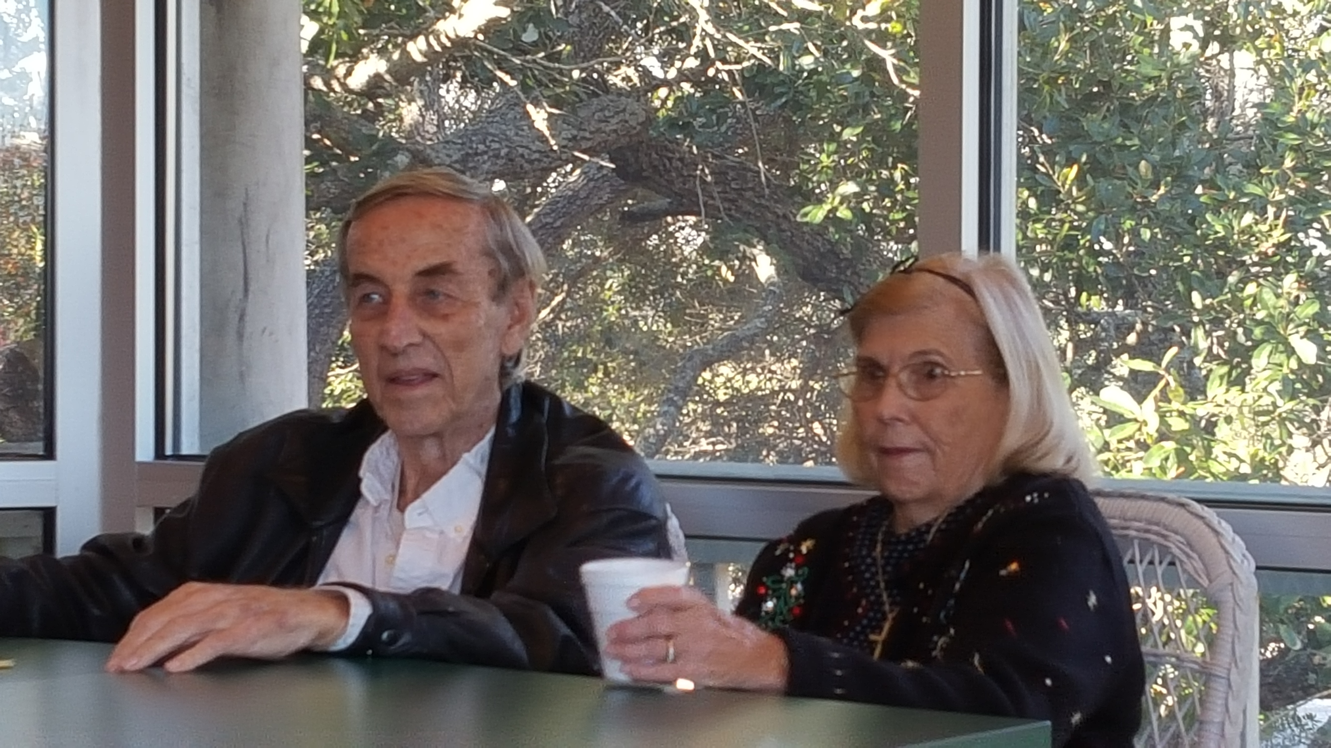
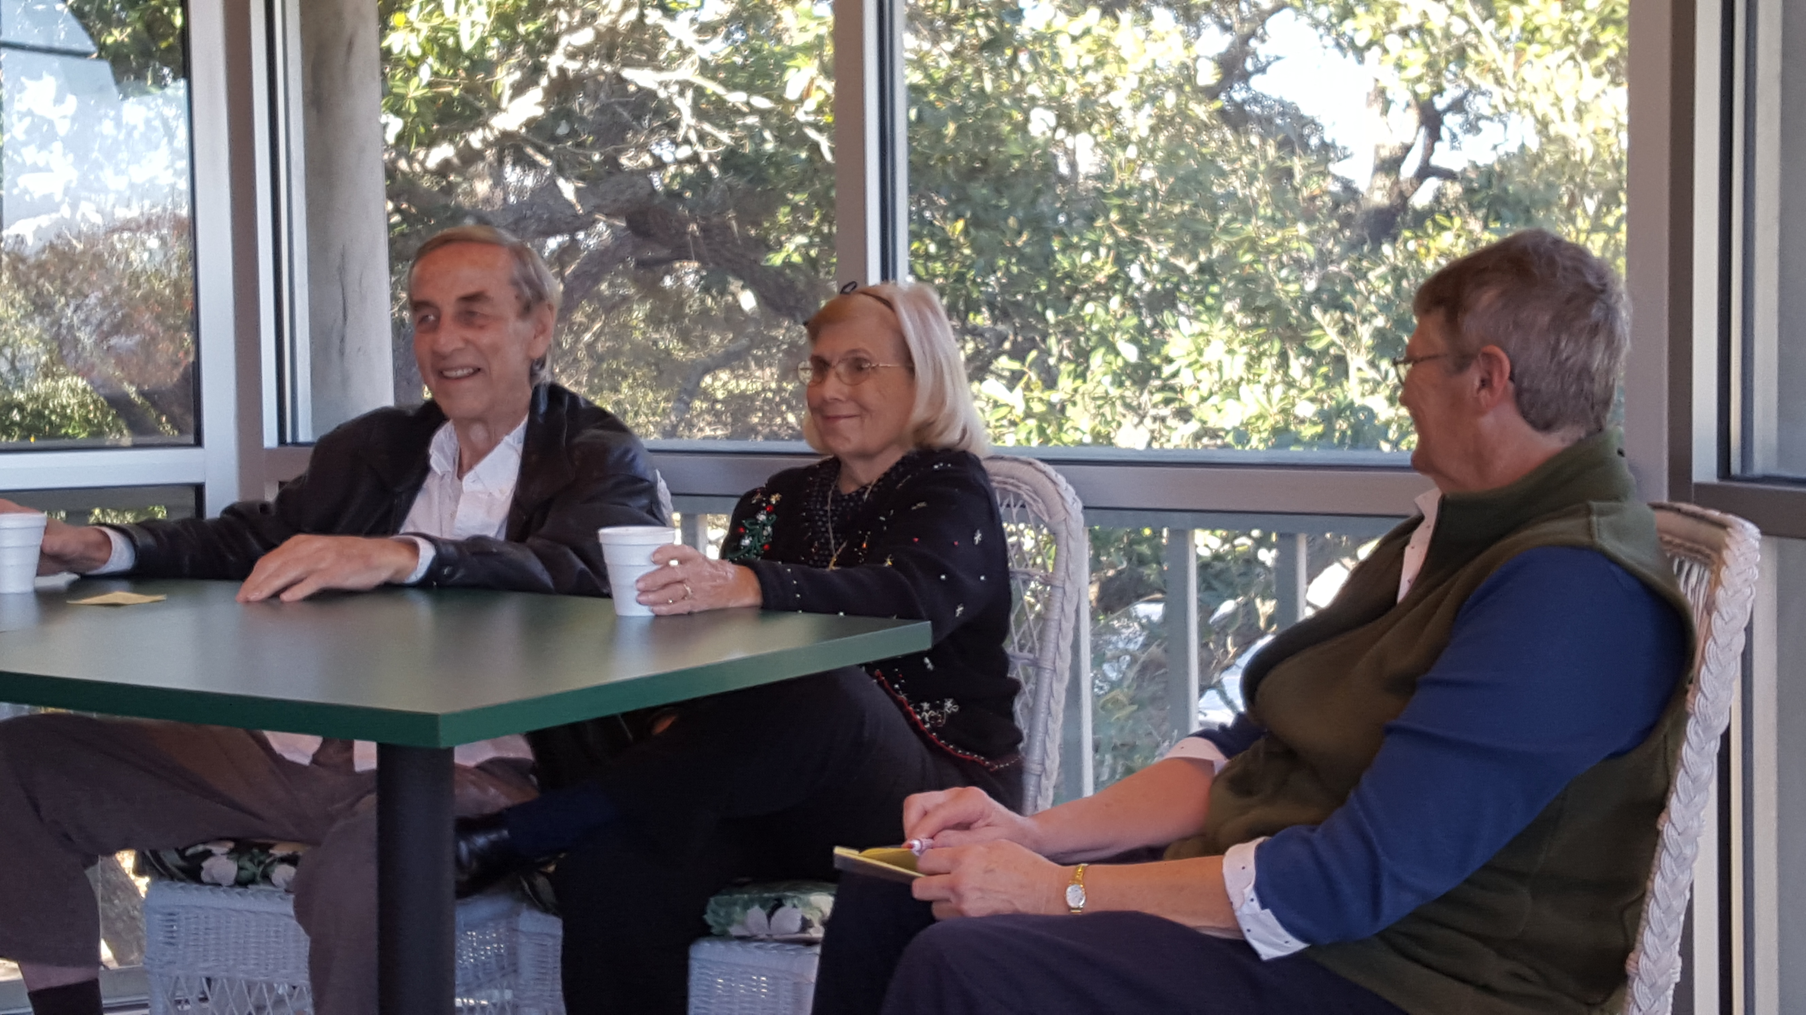

Our January program was given by Annette Goings. She discussed the use of values when creating a

painting. The program gave all of us in attendance an understanding of how to use value to enhance a composition, to create depth, etc. She discussed her art and the various media that she uses. Thanks to Annette for an interesting and informative program.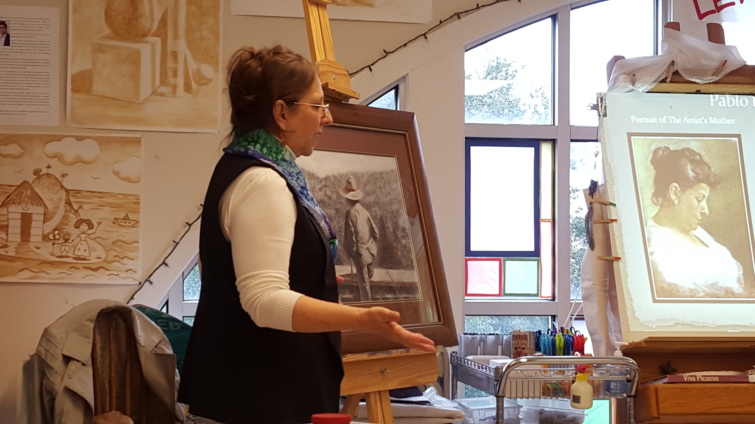

Scrapbook Project
We are still documenting the history of the Waccamaw Arts & Crafts Guild and we were about 80% complete. Due to recent work on the website, homeshow and initial preparation for the Juried Show this project is temporarily on hold. As indicated previously, we now have received additional information including additional scrapbooks, loose photos, etc. It will take some time to sort it out but our records will be significantly enhanced by this information. Once done, we will be able to add current information to the ongoing digital record. We hope to get back on track with this sometime soon.
New Website
The new website is up and running. We have experienced a few glitches, but it seems to be doing well. Check it out at wacg.org.
Opportunity
ART – Burger & Sushi Bar located at 706 North Ocean Blvd, Myrtle Beach, SC is a unique opportunity for our artists. They are willing to display works by local artists. Contact Linda Weatherspoon at (843)213-7127 or e-mail linda@jwxspoon.com, if you are interested in this opportunity.
Display Opportunity
The Waccamaw Art Center (formerly referred to as the Waccamaw Mall Gallery) is displaying works by local artists at the old Waccamaw Pottery Facility. If you haven’t seen it you may wish to visit this gallery which is located across from the Clarion Hotel. The gallery may be closing for about a week for painting, patching, and re-hanging the entire gallery after the recent Chinese Folk Art Show.
Local artists have an opportunity to display at this venue. There is a jurying process. Original art only. There is no fee to display in the gallery, however, a commission will apply to all sales and everyone must host the gallery at least 1 day a month (5 or 6 hour shift - current requirement).
Hosts will have an opportunity to earn 10% commission on items sold. The current commission is 30%. If this sounds interesting to you come by the gallery and check it out.
David Lee, the owner of the gallery, is a guild member.
Classes & Workshops
CLASSES:
Coastal Carolina Life Long Learning – Information at - www.coastal.edu/olli/
N. Myrtle Beach Rec Center – on Possum Trot Rd, NMB - http://parks.nmb.us/
Litchfield Exchange -http://www.classatpawleys.com/
Myrtle Beach Recreation Center –http://www.cityofmyrtlebeach.com/recreation.html
For information on workshops contact Ron at Southernexposuresandart@gmail.com or call (843)651-1388 or (843)655-1800

William H. Miller, 714 Main Street, Myrtle Beach is offering weekly figure drawing sessions on Wednesdays for 3 hours each. Live nude models. Fee $12 per session. For information whimdesigns@gmail.com or at (214)632-2809.

Members Who Teach
Susan Duke – watercolor, gouache & all water media, all skill levels. Tuesdays 10-12:30, her studio, 637 Grissom Pkwy, MB. Wednesdays 9:30-12:30 at B&C Museum. Classes on Mondays at Coastal Carolina 9:30- 12:30 – information at www.coastal.edu/olli/ or (843)251-3877
Stuart Fleishman – oils, acrylics, pastels, charcoal. Teaches use of brush and palette knife in oil and acrylic. Classes at NMB Rec Center, NMB Hobby Lobby, and Myrtle Beach A.C. Moore stores. Contact him at (843)213-1037 or fuforu@aol.com.
Brenda Lawson – beginner & intermediate watercolor lessons. Her studio is located behind Bistro 217 offering 3 hour classes in 6 week sessions. All supplies (brushes, paint, paper…) are included and will be the property of the student after the session concludes. Please call (843)360-0805 for session dates and prices or for info go to- www.pawleysislandartstudio.com
Jackie Stacharowski – Painting As A Hobby at the Base Rec Center in Market Common. All mediums, all skill levels (especially beginners) – Everyone works on their own projects at their own pace. Thursdays 9:00 AM – Noon, Starting September 3 – June come anytime. For info – (843)446-5749 or Jackie799@gmail.com
Linda Weatherspoon – teaches Art Therapy for Stroke Survivors once a month at Helpers Finders for the Grand Strand Hospital. Registration (843)692-4444 for Stroke Groups and Art Therapy. linda@jwxspoon.com (832)213-7127 www.lindaweatherspoon.com.blogspot.com
Rebecca Zdybel – All media
Water Media Wednesdays 1:00-4:00 PM – Explore watermedia and the many techniques and ways to paint. We use various media and approaches in this fun and popular class. Lectures, demos, and critique every class. Call 843-450-2307 for reservation. Seating limited, supplies available.
Saturday Art Studio 1-4 PM All media welcome in this class which caters to those who work or have busy weekday schedules. Lectures, demos, and critique every class. Call
843-450-2307 for reservation. Seating limited, supplies available.
Arty Party Private Classes – All materials provided to help your group paint together just for fun. Each participant will come away with a unique painting, hand painted scarf, or wine glass. You schedule the time that works for you and your group, I will provide all art materials. BYOB optional. Call 843-450-2307 to schedule.
Eat, Paint, Cook Tour of Tuscany – Sept 24th - Oct. 1, 2016
(Note – Painting and cooking are optional) beautiful scenery, great food, …visit Rebecca’s website for details. https://www.ilchiostro.com/workshops/eat-paint-cook-tour-of-tuscany/
Link to Rebecca’s website - http://artmyrtlebeach.com , http://www.coastal.edu/olli/courses.html Contact – website - rebeccazdybel.com or http://www.artmyrtlebeach.com/ (843)450-2307

Newsletter Info
If anyone has any news items for this newsletter please e-mail them to us at wacg.mbsc@gmail.com. To clarify,
we care about our fellow members their health, well-being and accomplishments. If you think something is newsworthy, please let me know about it.

One More Thing…
WACG has been promoting art in the area since 1969. Your membership provides access to engaging programs, art shows, opportunities to sell your work, discounts at local businesses, “members only” events and our newsletter. We appreciate your participation in the guild as we couldn’t do all of those good things without you.

The January 31st deadline has passed, but there is still time to renew your membership. We ask that everyone complete the entire membership form as it allows us to confirm and update your information. Please answer all questions, fill in all the blanks, and read carefully as the form has changed.
Attach your payment to the form and mail to Waccamaw Arts & Crafts Guild, PO Box 1595, Myrtle Beach, SC 29578.

Please help us get our records updated. If you have not yet paid your dues, please do so as soon as possible. A membership form is attached for your use.

Thanks for your help,

Tom Britton, Editor
Show & Communications Director
Waccamaw Arts & Crafts Guild

