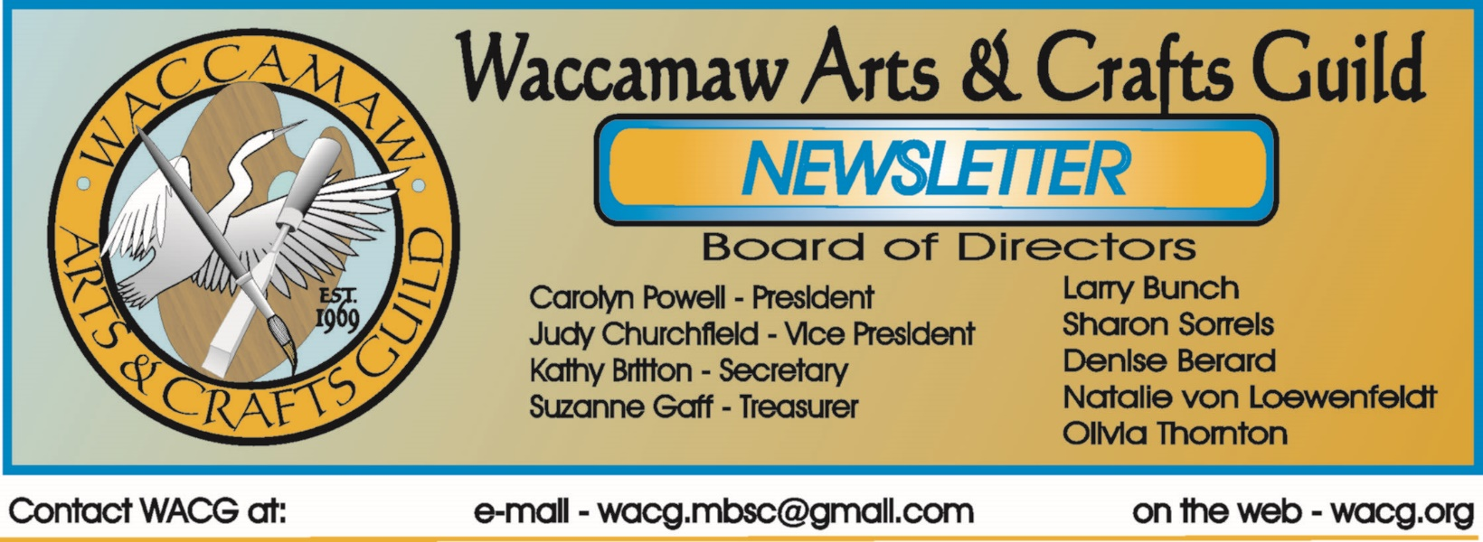
March 2016
Bits From The Board
The Board met after a wonderful presentation and mini-workshop by Rebecca Zdybel. There was a good crowd, but more of you need to come out to the monthly meetings and enjoy time with fellow artists. We miss your input and expertise!

The Home Show proved to be very successful. Fourteen artists participated and collectively sold in excess of $3000, ten percent of which goes into the Guild’s coffers. We met many people who were interested in the arts and our organization. Thanks to the participants for their hard work.

Tom Britton updated us on the juried show and our social media presence.

The Board voted unanimously to extend a lifetime membership to Alex Powers for his role in establishing the Guild.

Art in the Park events resume next month and the Juried Show at the end of April. Hope to see everyone at these events.

Kathryn Martin of Surfside Beach announced an upcoming event bringing beach themed music, art, and food to the South Strand on June 26th – more information in this newsletter. Sounds like a great opportunity for artists to show and perhaps sell their art.

Carolyn Powell, President

Imagine, Create, Enjoy…
Looking Back
The original WACG logo was designed by John Henry and was recently updated by Tom Britton.
A commercial artist from Chicago, Henry studied at the Harris School of Art in Nashville and the American Academy of Art in Chicago. He created thousands of ads over a thirty-five year career.
Once here, he believed that “Myrtle Beach can be an artistic resort, not just a T-shirt capital…I think we are missing a good market.”
Henry worked in oils and watercolors as a professional artist along the Grand Strand. His home was cluttered with artwork everywhere; on walls, leaning against walls and tables, and on easels. Beach scenes and portraits were his passions; he also made puppets, musical instruments and sculptures.
Carolyn Powell, President
Show Dates
WACG Juried Show – (MB Art Museum)
April 28 – May 26
All entries have been received and the jury process is proceeding. We will provide the results by March 18th. Thanks to all who entered and good luck.

Art in the Park – (Chapin Park)
April 9th & 10th
June 11th & 12th
October 8th & 9th
November 5th & 6th

Art in the Park – (Valor Park)
April 16th & 17th
November 12th & 13th

Home Show – (Convention Center)
September TBD

Members Judged Show – (Seacoast Gallery)
October TBD
More information to follow.
Other Show I Event Info
The Myrtle Beach Art Museum has some interesting shows running until early to mid - April. You will probably want to check these out.

Frank Lloyd Wright: Architecture of the Interior
January 5th – April 7th
Recognized around the world for his innovative style and modern designs, Frank Lloyd Wright originated and popularized the concept that structures should exist in harmony with humanity and the environment, a philosophy he called organic architecture. The concept extended not only to structures’ exteriors, but also to the interiors, furnishings and ornaments. The exhibition includes drawings, photographs of his most distinctive interiors.

Joe Quinn: Underwater
January 14th – April 21st
Originally from New York City, Quinn now lives in Myrtle Beach. He is a professional photographer who specializes in underwater, nature, documentary and fine art imagery. He is a member of the Ocean Artists Society and his work has been published in Asian Geographic, National Geographic, Smithsonian, and Dive News.

Charles Clary Infect[ious] Installations

Charles Clary of Morristown, TN currently teaches studio art at Coastal Carolina University. Using hand-cut, layered paper to build intriguing land formations that mimic viral colonies and concentric sound waves. His show presents us with the ideas of order out of chaos, beauty from destruction and hope for more joyous times

Kirkland Smith: Assemblages
January 21st – April 21st
Kirkland Smith was born in Charleston, South Carolina and currently resides in Columbia, SC. She earned a BA degree for the University of South Carolina in Studio Arts, concentrating on ceramics and sculpture. In 2008, Kirkland entered an environmental art contest and almost by accident began creating contemporary assemblages from post-consumer materials.

Other Show I Event Info
The Rebecca Randall Bryan Gallery at CCU has a new exhibit featuring life-size charcoal drawings of artist Denise Stewart-Sanabria. The show opened February 29th and will be on display until April 1st. The show “Quantum Continuum” is about placing people in various conceptual situations. The show is located in the Edwards Building room 129 located at 133 Chanticleer Drive on the main campus of CCU.
Meetings
Our February meeting included a program by Rebecca Zdybel involving encaustic techniques and uses. Everyone really enjoyed the presentation and they certainly enjoyed the “hands-on” portion where they got to work with the wax, Tjaps, and watercolor to create their own artwork. Thanks to Rebecca for a wonderful program.

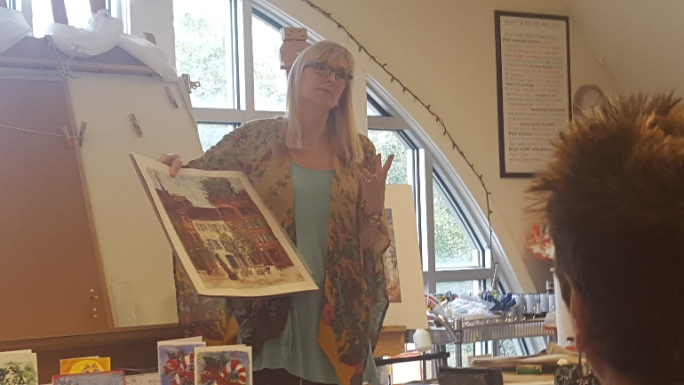
Rebecca Zdybel discussing encaustic.
Our next regular monthly meeting will be on March 20th, at 1:30 PM at the Myrtle Beach Art Museum. Mark your calendars. The program will be presented by Elaine Goodman.
Born and raised in Pittsburg, Pa she earned her BFA degree from Pratt Institute in 1973. The published and award winning artist that, “From the Crayola 64 box of colors to all the color chips in my father’s paint store, color has always been a delight and source of excitement. From the soft whispers of color, to the electric dazzling colors, I am drawn into a musical world. I paint attitude, shape, and color. Attitudes range from humor to loneliness and everything in between. Art becomes my companion and my teacher, where inner feelings are explored. My work has been described as “outsider, expressive, or intuitive.” She lives in the area with her husband and two dogs.
Do make plans to be at the museum on March 20th to meet Elaine, enjoy her program, learn more about this talented artist, and see some of her artwork.
Scrapbook Project
We are still documenting the history of the Waccamaw Arts & Crafts Guild and we were about 80% complete. We received additional information including additional scrapbooks, loose photos, etc. It will take some time to sort it out but our records will be significantly enhanced by this information. Once done, we will be able to add current information to the ongoing digital record. We hope to get back on track with this project sometime soon.

New Website
The new website is up and running and we have received a number of inquiries as a result. We have experienced a few glitches, but it seems to be doing well. Check it out at wacg.org.
Display Opportunity
The Waccamaw Art Center (formerly referred to as the Waccamaw Mall Gallery) is displaying works by local artists at the old Waccamaw Pottery Facility. If you haven’t seen it lately, it has changed a lot, and continues to evolve.
Local artists have an opportunity to display at this venue. There is a jurying process. Original art only. There is no fee to display in the gallery, however, a commission will apply to all sales and everyone must host the gallery at least 1 day a month (5 or 6 hour shift - current requirement). Hosts will have an opportunity to earn a 5-10% commission on items sold.
Display Opportunity
The town of Surfside Beach is looking for artists for a beach music, art and food festival “Surfside’s Up” on June 26th. The event will be held at the Surfside Beach Civic Center. All arts and media are eligible and must be beach themed. Information and entry forms will be available shortly at Surfside Beach.org. Submissions must be made by May 27th. Check it out.

Display Opportunity
We were recently contacted by the Myrtle Beach Corvette Club regarding the upcoming Corvettes At The Beach event on June 4th at Broadway At The Beach. They are looking for vendors of all kinds and if you are interested you may contact Linda Meaders at 843-340-1731 or via e-mail at lmeaders@frontier.com.

Opportunity
Alex Powers has informed us that he has reduced the prices of all of his artwork located at City Art Gallery in Columbia, SC by 50%. Sales have increased so he decided to reduce the prices of ALL of his artwork. At this point everything has been marked down except the works located on his website which are 50% less than the posted price. He is also offering free shipping for unframed paintings and drawings in the U.S. His website is www.AlexPowersArt.com. If you have been waiting for an opportunity to obtain some of Alex’s work, it is here now.

Classes & Workshops
CLASSES:
Coastal Carolina Life Long Learning – Information at - www.coastal.edu/olli/
N. Myrtle Beach Rec Center – on Possum Trot Rd, NMB - http://parks.nmb.us/
Litchfield Exchange -http://www.classatpawleys.com/
Myrtle Beach Recreation Center –http://www.cityofmyrtlebeach.com/recreation.html
For information on workshops contact Ron at Southernexposuresandart@gmail.com or call (843)651-1388 or (843)655-1800

William H. Miller, 714 Main Street, Myrtle Beach is offering weekly figure drawing sessions on Wednesdays for 3 hours each. Live nude models. Fee $12 per session. For information whimdesigns@gmail.com or at (214)632-2809.

Members Who Teach
Susan Duke – watercolor, gouache & all water media, all skill levels. Tuesdays 10-12:30, her studio, 637 Grissom Pkwy, MB. Wednesdays 9:30-12:30 at B&C Museum. Classes on Mondays at Coastal Carolina 9:30- 12:30 – information at www.coastal.edu/olli/ or (843)251-3877
Stuart Fleishman – oils, acrylics, pastels, charcoal. Teaches use of brush and palette knife in oil and acrylic. Classes at NMB Rec Center, NMB Hobby Lobby, and Myrtle Beach A.C. Moore stores. Contact him at (843)213-1037 or fuforu@aol.com.
Jackie Stacharowski – Painting As A Hobby at the Base Rec Center in Market Common. All mediums, all skill levels (especially beginners) – Everyone works on their own projects at their own pace. Thursdays 9:00 AM – Noon, Starting September 3 – June come anytime. For info – (843)446-5749 or Jackie799@gmail.com
Rebecca Zdybel – All media
Water Media Wednesdays 1:00-4:00 PM – Explore watermedia and the many techniques and ways to paint. We use various media and approaches in this fun and popular class. Lectures, demos, and critique every class. Call 843-450-2307 for reservation. Seating limited, supplies available.
Saturday Art Studio 1-4 PM All media welcome in this class which caters to those who work or have busy weekday schedules. Lectures, demos, and critique every class. Call
843-450-2307 for reservation. Seating limited, supplies available.
Arty Party Private Classes – All materials provided to help your group paint together just for fun. Each participant will come away with a unique painting, hand painted scarf, or wine glass. You schedule the time that works for you and your group, I will provide all art materials. BYOB optional. Call 843-450-2307 to schedule.
Eat, Paint, Cook Tour of Tuscany – Sept 24th - Oct. 1, 2016
(Note – Painting and cooking are optional) beautiful scenery, great food, …visit Rebecca’s website for details. https://www.ilchiostro.com/workshops/eat-paint-cook-tour-of-tuscany/
Link to Rebecca’s website - http://artmyrtlebeach.com , http://www.coastal.edu/olli/courses.html Contact – website - rebeccazdybel.com or http://www.artmyrtlebeach.com/ (843)450-2307

Newsletter Info
If anyone has any news items for this newsletter please e-mail them to us at wacg.mbsc@gmail.com. To clarify,
we care about our fellow members their health, well-being and accomplishments. If you think something is newsworthy, please let me know about it.

One More Thing…
The January 31st deadline has passed, but there is still time to renew your membership. We ask that everyone complete the entire membership form as it allows us to confirm and update your information. Please answer all questions, fill, in all blanks, and read carefully as the form has changed.

Attach your payment to the form and mail to:

Waccamaw Arts & Crafts Guild, PO Box 1595, Myrtle Beach, SC 29578

Please help us get our records updated. If you have not yet paid your dues, please do so as soon
as possible. If you have not renewed this will be your last newsletter, so don’t miss out. Also, non-members do not get advertising in the Members who teach section. A membership form is available at our website.

Tom Britton, Editor
Show & Communications Director
Waccamaw Arts & Crafts Guild

