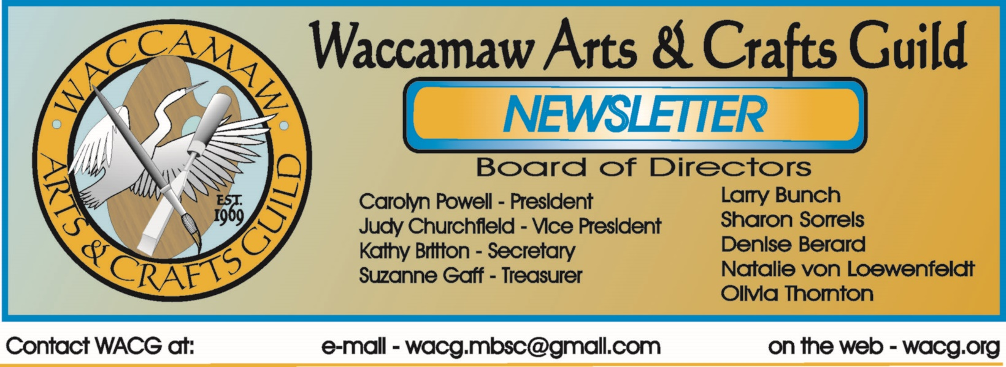
April 2016
Bits From The Board
Our March speaker, Elaine Goodwin, found a large audience for her talk about her art and art philosophy at the general meeting. It was lovely to see so many artists and art lovers there.
The Board met briefly afterward. Kathy Britton distributed letters to go out to potential sponsors for our upcoming juried show. All members will reach out to at least ten businesses.
Sharon Sorrels and Olivia Thornton updated us about the status of high school scholarships.
Larry Bunch will contact technical people at Coastal to see about how to finish our DVD of the recent conversation with Dixie Dugan and Alex Powers about the history of the Guild.
We have a busy month coming up, with the juried show and two Art in the Park weekends. Those artists whose work was accepted for the show should have their insurance and signage information in to the Museum by April 4. Intake of the pieces will be at the museum on the morning of April 22. In all, as per requested by the museum, seventy five pieces were accepted.
We look forward to seeing everyone at these events.

Carolyn Powell, President

Imagine, Create, Enjoy…
Looking Back
The very first Art in the Park, with ten artists participating, was held in 1973. Even though it wasn't very successful, "It let people know we were here," according to WACG charter member Dixie Dugan.
As she recalled, "we kinda huddled together and brought our picnic lunches...We laugh at it now because if it hadn't been for our families, nobody would have come."(Sun News)
Within a dozen years, the event was attracting up to one hundred artists from all over the Southeast. In 1985, eighty five exhibitors were invited to show their work, including outdoor artist Steve Humphreys, who demonstrated chain saw carving.
Art in the Park 2016 gets underway this month.

Carolyn Powell, President
Spring is Here!
This is the season when we begin to see the “warm” colors…..YELLOW is an example. Even though yellow is a nice primary color that helps to create the green of summer, some of us are ready for it to go away until next year! I’m ready.
Tom Britton
Show Dates
WACG Juried Show – (MB Art Museum)
April 28 – May 26
REMEMBER – accepted artwork must be delivered to the museum between 9:00 am and noon on Friday, April 22nd. Please be sure that the work is properly prepared for display.

Art in the Park – (Chapin Park)
April 9th & 10th
June 11th & 12th
October 8th & 9th
November 5th & 6th

Art in the Park – (Valor Park)
April 16th & 17th
November 12th & 13th

Home Show – (Convention Center)
September TBD

Members Judged Show – (Seacoast Gallery)
October TBD
More information to follow.
Other Show I Event Info
The Myrtle Beach Art Museum has some interesting shows running until early to mid - April. You will probably want to check these out.

Joe Quinn: Underwater
January 14th – April 21st
Originally from New York City, Quinn now lives in Myrtle Beach. He is a professional photographer who specializes in underwater, nature, documentary and fine art imagery. He is a member of the Ocean Artists Society and his work has been published in Asian Geographic, National Geographic, Smithsonian, and Dive News.

Charles Clary Infect[ious] Installations
January 21st – April 21st
Charles Clary of Morristown, TN currently teaches studio art at Coastal Carolina University. Using hand-cut, layered paper to build intriguing land formations that mimic viral colonies and concentric sound waves. His show presents us with the ideas of order out of chaos, beauty from destruction and hope for more joyous times

Kirkland Smith: Assemblages
January 21st – April 21st
Kirkland Smith was born in Charleston, South Carolina and currently resides in Columbia, SC. She earned a BA degree for the University of South Carolina in Studio Arts, concentrating on ceramics and sculpture. In 2008, Kirkland entered an environmental art contest and almost by accident began creating contemporary assemblages from post-consumer materials.

The Waccamaw Arts & Crafts Guild 19th Annual Juried Show at the Myrtle Beach Art Museum April 28th – May 26th.

Other Show I Event Info
Graduating seniors from Coastal Carolina University’s Department of Visual Arts with a focus in art studio will present their thesis exhibitions in “Portfolios I” April 8-19 in the Rebecca Randall Bryan Art Gallery in the Thomas W. and Robin W. Edwards College of Humanities and Fine Arts. An opening reception will be held in the gallery from 4:30 to 6:30 p.m. on Friday, April 8. Both the exhibit and the reception are free and open to the public.
“Portfolios” will feature works by art studio students Ashley Arakas, Sarah Cox, Elisabeth Dollar and Rebecca Jolly, all of Myrtle Beach; Katherin Farrelly, of Denville, N.J.; Jermaine Gourdaine, of Saint Stephen; Jessica Schwiers of Murrells Inlet; and Arianna Sellers of Ruby.
The gallery is in Room 129 of the Edwards Building at 133 Chanticleer Drive W. on the main campus.
The gallery is open from 9 a.m. to 5 p.m. Monday through Friday. For additional information, contact gallery director James Arendt at 843-349-6409.

Meetings
Our March program was presented by Elaine Goodman. She discussed her thoughts on art and discussed some of her works. The program was enjoyed by all.
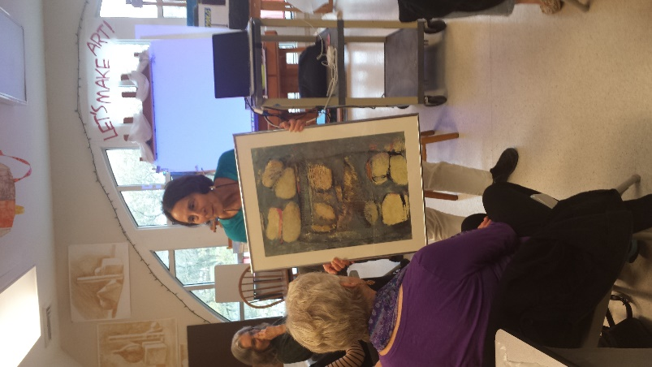
Born and raised in Pittsburg, Pa she earned her BFA degree from Pratt Institute in 1973. The published and award winning artist that, “From the Crayola 64 box of colors to all the color chips in my father’s paint store, color has always been a delight
and source of excitement. From the soft whispers of color, to the electric dazzling colors, I am drawn into a musical world. I paint attitude, shape, and color. Attitudes range from humor to loneliness and everything in between. Art becomes my companion and my teacher, where inner feelings are explored.
IMPORTANT – Due to a conflict in scheduling our April meeting will be on the 24th of the month at 1:30 pm. Please join us at the museum for a wonderful program by three talented seniors from CCU, Ashley Arakas, Rebecca Jolly, and Haley Smith, who will present examples of their work and discuss them. This should be a very interesting program. Hope to see you there.
Scrapbook Project
Due to a number of ongoing projects and the spring show this project has been delayed. Don’t lose hope…it will get done. We have so much information, the big issue now is how to get it all to fit on a couple of DVDs, We still need to process a lot of loose items and seven or eight more old scrapbooks.
New Website
We continue to receive a number of inquiries from the website. We are now starting to work on Facebook and associated links. Our Board member, Denise Berard, will be working on this for us and Three Ring Focus is helping to bring it all together.
Display Opportunity
The Waccamaw Art Center (formerly referred to as the Waccamaw Mall Gallery) is displaying works by local artists at the old Waccamaw Pottery Facility. If you haven’t seen it lately, it has changed a lot, and continues to evolve.
Local artists have an opportunity to display at this venue. There is a jurying process. Original art only. There is no fee to display in the gallery, however, a commission will apply to all sales and

everyone must host the gallery at least 1 day a month (5 or 6 hour shift - current requirement). Hosts will have an opportunity to earn a 5-10% commission on items sold.
Display Opportunity
The town of Surfside Beach is looking for artists for a beach music, art and food festival “Surfside’s Up” on June 26th. The event will be held at the Surfside Beach Civic Center. All arts and media are eligible and must be beach themed. Information and entry forms will be available shortly at Surfside Beach.org. Submissions must be made by May 27th. Check it out. Contact Kathryn Martin at (843)503-0293 or at martinkathryn@yahoo.com.

Display Opportunity
We were recently contacted by the Myrtle Beach Corvette Club regarding the upcoming Corvettes At The Beach event on June 4th at Broadway At The Beach. They are looking for vendors of all kinds and if you are interested you may contact Linda Meaders at 843-340-1731 or via e-mail at lmeaders@frontier.com.

Opportunity
"2016's National Art Honor Society and National Junior Art Honor Society's Conference will be held at the Columbia Museum of Art on Saturday, April 23rd, 2016. Registration will begin promptly at 9 am. There will be three sessions (classes) as well as lunch. The final session of the day will conclude at 3:30 pm. The cost for registration, lunch and a t-shirt is $10. Please contact the SCAEA Secondary Coordinator, Olivia Thornton, at OThornton@horrycountyschools.net as soon as possible if you are interested in attending the conference and/or teaching a session. Thank you."

Classes & Workshops
CLASSES:
Coastal Carolina Life Long Learning – Information at - www.coastal.edu/olli/
N. Myrtle Beach Rec Center – on Possum Trot Rd, NMB - http://parks.nmb.us/
Litchfield Exchange -http://www.classatpawleys.com/
Myrtle Beach Recreation Center –http://www.cityofmyrtlebeach.com/recreation.html
For information on workshops contact Ron at Southernexposuresandart@gmail.com or call (843)651-1388 or (843)655-1800

William H. Miller, 714 Main Street, Myrtle Beach is offering weekly figure drawing sessions on Wednesdays for 3 hours each. Live nude models. Fee $12 per session. For information whimdesigns@gmail.com or at (214)632-2809.

Members Who Teach
Susan Duke – watercolor, gouache & all water media, all skill levels. Tuesdays 10-12:30, her studio, 637 Grissom Pkwy, MB. Wednesdays 9:30-12:30 at B&C Museum. Classes on Mondays at Coastal Carolina 9:30- 12:30 – information at www.coastal.edu/olli/ or (843)251-3877
Stuart Fleishman – oils, acrylics, pastels, charcoal. Teaches use of brush and palette knife in oil and acrylic. Classes at NMB Rec Center, NMB Hobby Lobby, and Myrtle Beach A.C. Moore stores. Contact him at (843)213-1037 or fuforu@aol.com.
Jackie Stacharowski – Painting As A Hobby at the Base Rec Center in Market Common. All mediums, all skill levels (especially beginners) – Everyone works on their own projects at their own pace. Thursdays 9:00 AM – Noon, Starting September 3 – June come anytime. For info – (843)446-5749 or Jackie799@gmail.com
Rebecca Zdybel – All media
Water Media Wednesdays 1:00-4:00 PM – Explore watermedia and the many techniques and ways to paint. We use various media and approaches in this fun and popular class. Lectures, demos, and critique every class. Call 843-450-2307 for reservation. Seating limited, supplies available.
Saturday Art Studio 1-4 PM All media welcome in this class which caters to those who work or have busy weekday schedules. Lectures, demos, and critique every class. Call
843-450-2307 for reservation. Seating limited, supplies available.
Arty Party Private Classes – All materials provided to help your group paint together just for fun. Each participant will come away with a unique painting, hand painted scarf, or wine glass. You schedule the time that works for you and your group, I will provide all art materials. BYOB optional. Call 843-450-2307 to schedule.
Eat, Paint, Cook Tour of Tuscany – Sept 24th - Oct. 1, 2016
(Note – Painting and cooking are optional) beautiful scenery, great food, …visit Rebecca’s website for details. https://www.ilchiostro.com/workshops/eat-paint-cook-tour-of-tuscany/
Link to Rebecca’s website - http://artmyrtlebeach.com , http://www.coastal.edu/olli/courses.html Contact – website - rebeccazdybel.com or http://www.artmyrtlebeach.com/ (843)450-2307

Brenda Lawson – beginner & intermediate watercolor lessons. Her studio is located behind Bistro 217 offering 3 hour classes in 6 week sessions. All supplies (brushes, paint, paper…) are included and will be the property of the student after the session concludes. Please call (843)360-0805 for session dates and prices or for info go to- www.pawleysislandartstudio.com
Newsletter Info
If anyone has any news items for this newsletter please e-mail them to us at wacg.mbsc@gmail.com. To clarify,
we care about our fellow members their health,
well-being and accomplishments. If you think
something is newsworthy, please let me know about it.

Important – For those who teach please check the information on your classes for any needed changes and keep me current so we can pass along correct information.

One More Thing…
Art In The Park is starting up again this year beginning on the 9th at Chapin Park. See the schedule for dates and locations.

It is almost time for the Juried Show at the museum. If you made it into the show, congratulations. If you didn’t….there is always the fall show or the Juried Show next spring. That’s the way I look at it. No problem….The sun will come up tomorrow……or not. Seriously, whether you made it in or not come see the show and enjoy our special time at the museum.

Tom Britton, Editor
Show & Communications Director
Waccamaw Arts & Crafts Guild

